Practical 3
Implementation of Infrastructure as a Service using Windows HyperV
(Windows Server 2012 R2)

- In the VM ware Workstation Create a new Virtual Machine
- Click Custom next
- Hardware Compatibility - Workstation 14.x
- Next
- Install from - select I will install Operating Sytem later
- Select a Guest OS - select Microsoft Windows & version - Windows Server 2012
- Name the Virtual Machine and save it in a new folder
- Firmware type - BIOS
- Processor Configuration - 2 & 1
- Memory for the VM - 4GB (4096)
- Network Type - NAT
- Select I/O controller types - LSI Logic SAS (Recommended)
- Select a Disk Type - SCSI
- Select a Disk - Create a new Virtual disk
- Specify Disk Capacity - 60 & Store Virtual disk as a single file
- Specify Disk File - Browse and save in the same earlier VM folder
- Then Finish

- Go to Edit Virtual Machine Settings
- Hardware > CD/DVD (SATA) - tick connect at power on
- and tick Use ISO image file - 9600.16384.130821...
- Then Power on the VM
- Then in Language keep as it is
- Click Install Now
- Enter the Product Key - Windows Server 2012 R2 Standard is D2N9P-3P6X9-2R39C-7RTCD-MDVJX (U can find this in the Local server )
- Next
- Select the Windows Server 2012 R2 Standard (Server with GUI) > Next
- Tick I accept the license terms > Next
- Type of Installation - Custom: Install Windows only (advanced)
- Next
- Create the password then login
- From the side panel of this Server manager > Local Server > Properties below you will find Computer Name
- Now change the computer name by click and change and then enter the name inside the textbox and click on OK.
- Click on OK when it prompts restart the computer and then click on restart now and the step up will be completed.

- Now Adding Hyper-V feature in windows server 2012 and create a virtual machine.
- Click on manage (Its on right top corner tabs) then click on Add Roles and features.
- Select the server and click next.
- In Server Roles select Hyper-V then click on Add
- features and click on next. (Will not work)

- Then Power off the Virtual Machine then go to edit virtual machine settings in that options tab in version select hyper-V (not supported)
- Then Now Power on the VM Again try to add the Hyper-V Feature
- Tick the Hyper -V > Next
- Click Add Feature
- Now in Features Tick .NET Framework 3.5 features
- Next
- Tick the Ethernet0 in Virtual Switches > Next
- In Migration tick the checkbox to allow this server to send and receive live migartions of virtual machines > Next
- Next
- In Confirmation Click on Install
- Now Restart the Server
- After Power On , Now Login and Click on tools tab (Its at the right top corner tabs) and select the Hyper-V Manager
- Now Right click on the server > New > Virtual Machine
- Name the VM > Next
- Tick Generation 1 > Next
- Change the assign memory to 2048MB > Next
- Select The Configure Networking as Intel(R) 82574 Gigabit Network Connection - Virtual Switch
- Select the Virtual Hard Disk - Hyper-V (Virtual HArd Disk) and Size - 40GB > Next
- Now In Installation Options Select Install an operating system later > Next
- Finish
- Go to the Internet Explorer > Open the Local Server (192.168.2.2)
- And Download the en_Windows_7_Ultimate OR the Windows7_all in one (whichever u find)
- Assign the ISO File as below -
1.Open Hyper-V Manager.
2.Select the created Virtual Machine from the list.
3.Right-click on the virtual machine and click Settings.
4.In the left panel, select DVD Drive.
5.Choose the option Image file (.iso).
6.Click on Browse and select the ISO file from the drive where u downloaded it.
- Select the Virtual Machine and click on start from the right side panel
- Complete the Installation Process
- FINISH

Step1- Open VMWare and Select create a virtual machine and click on next.

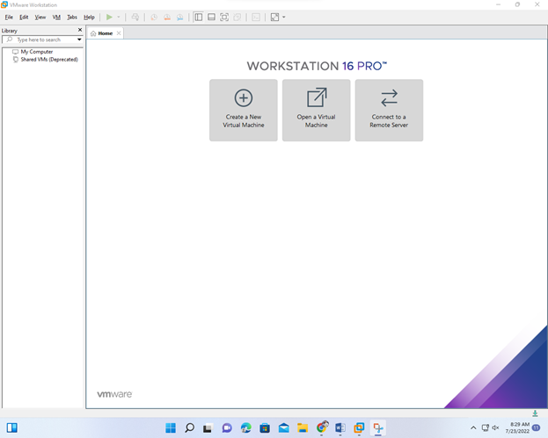
Click on Custom.
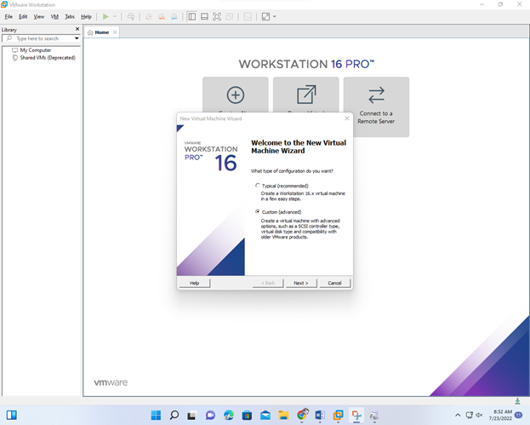

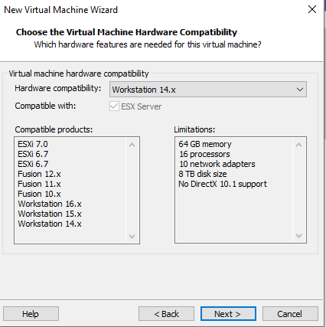

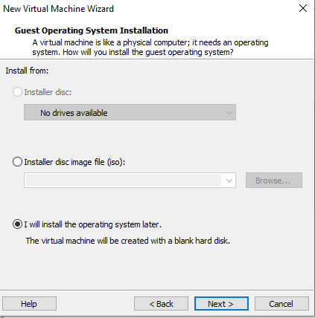
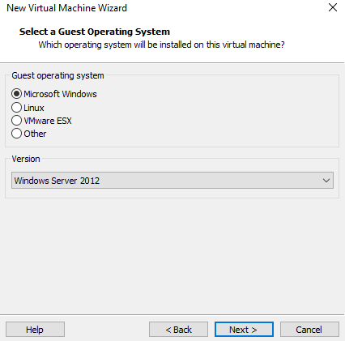
Step3-Select location and folder where you want to store the virtual machine.
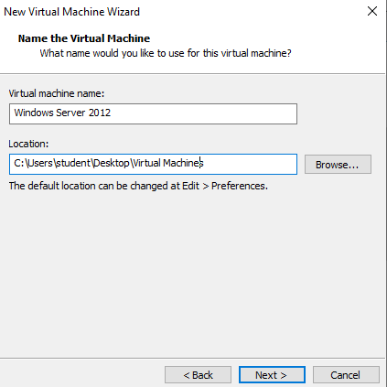

Step4-Select default one as BIOS and click next.
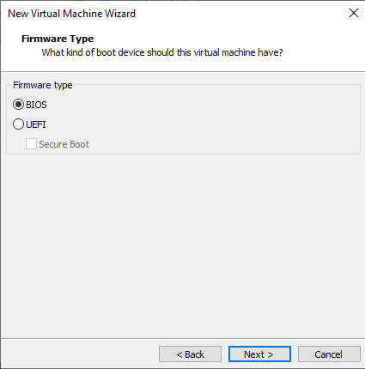
Step5- Select the number of processor as 2 and click next.
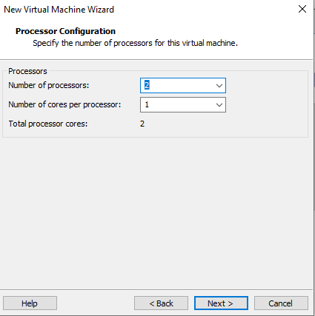
Step6- Select the amount of RAM as 4GB and click on next.
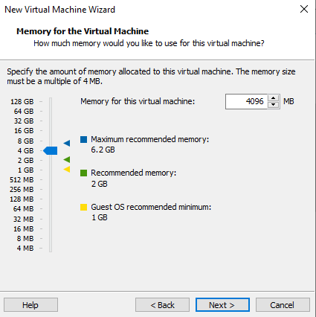
Step7-Select NAT as host IP address and click on next.
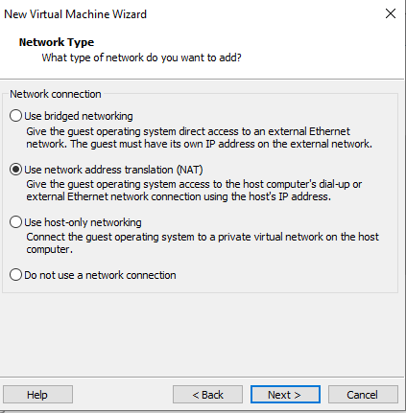
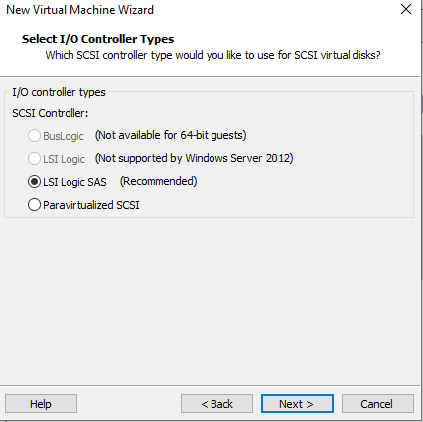
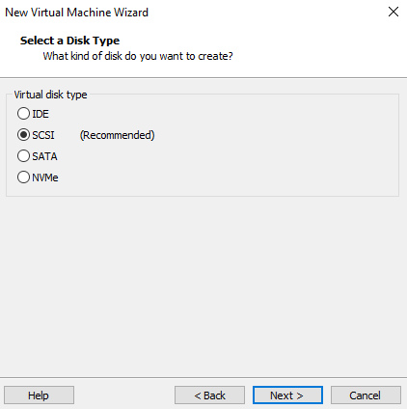
Step8-Select create a virtual disk and click on next.
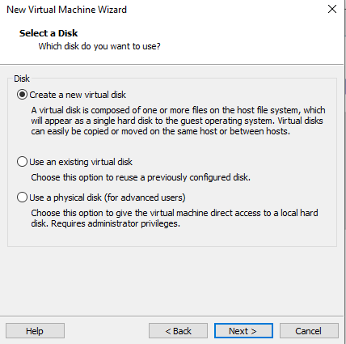
Step9-Enter amount of workspace as 60 GB and select store virtual disk as single file and click on next.
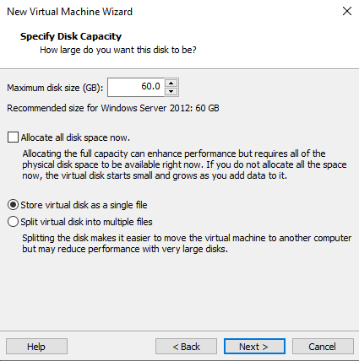
Step10-Store it in same location and folder and click on next and finish.
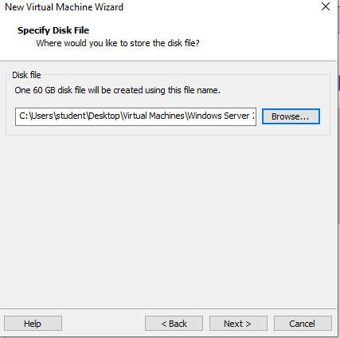
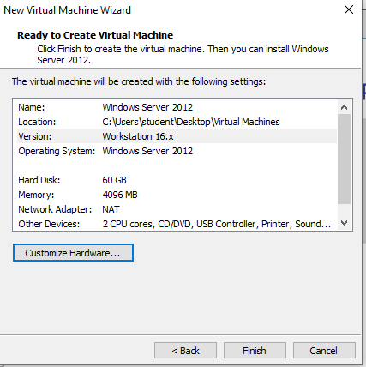
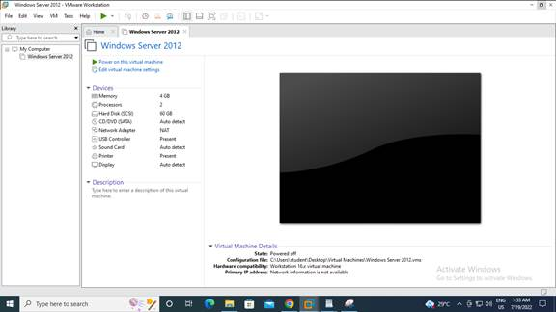

Step11-Windows Server virtual machine is created so now add the image file so select CD/ DVD .
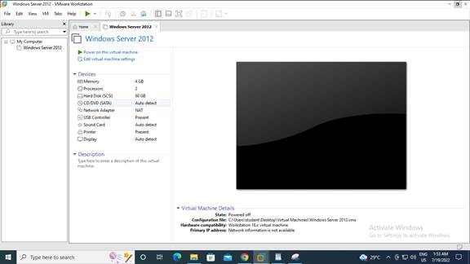
Step12-Browse and select the image file and click on ok.
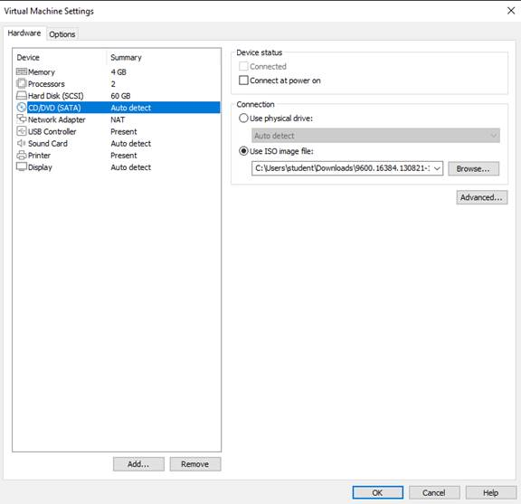

Step13-Click on power on virtual machine.

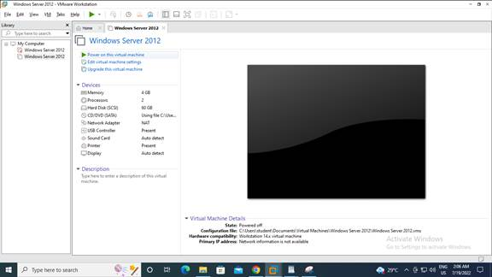
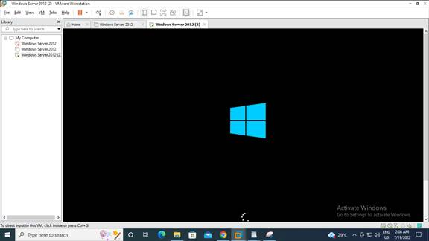
Step14- Select English as language and click next.
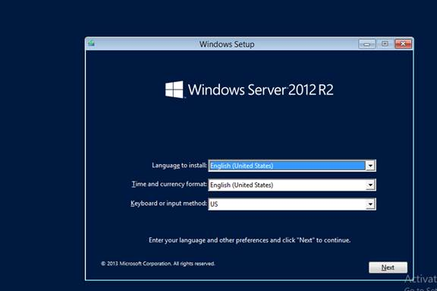
Step15-Click Install now.
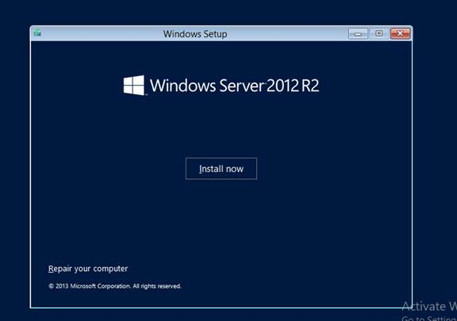
Step16-Enter product key and select GUI installation and click on next.
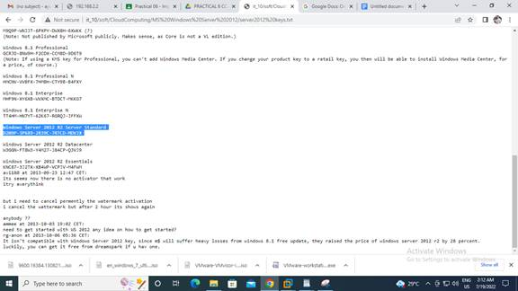
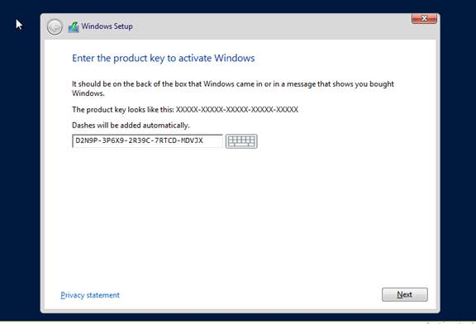
Step16-Enter product key and select GUI installation and click on next.
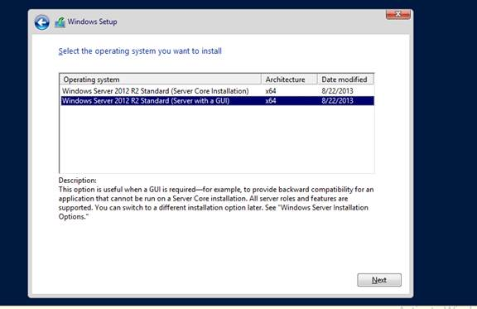
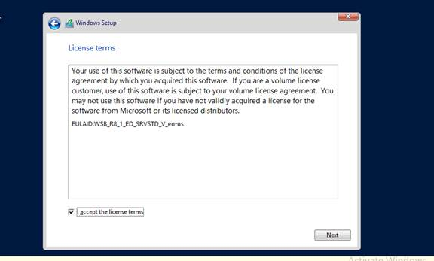
Step17- Click on custom installation and click on next.

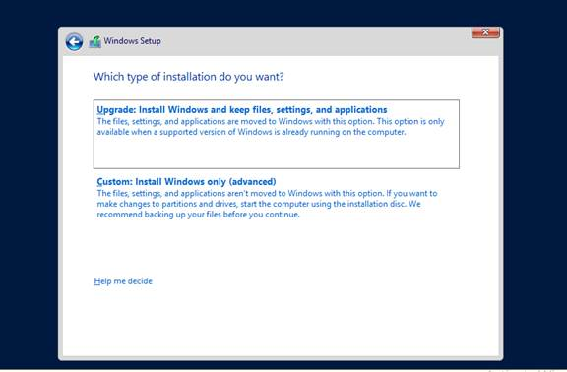
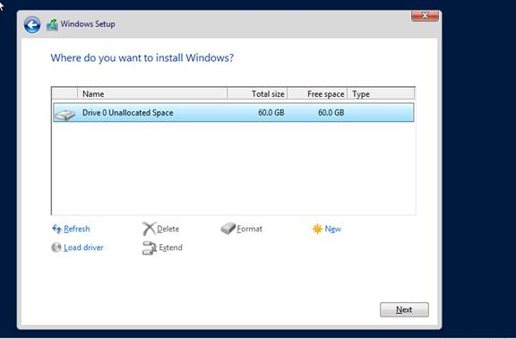
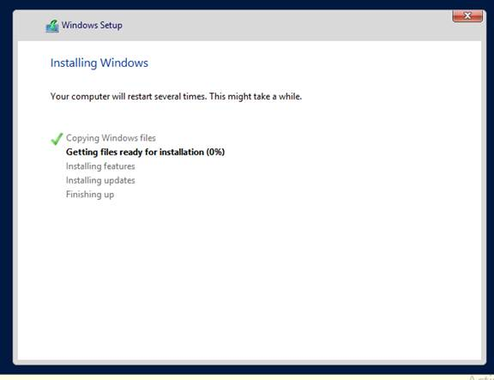
Step18- Now login to the server and provide the administration password and click on next.
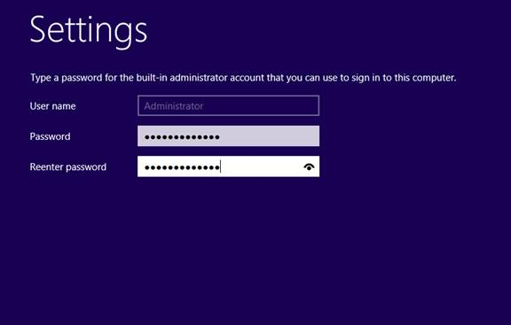
Password – Student@123
Step19-Now change the computer name by click on change and then enter the name inside the textbox and click on OK.
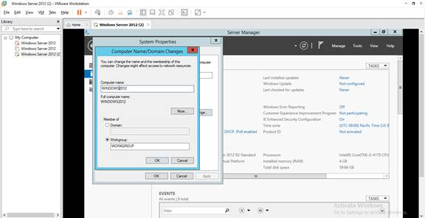
Step20- Click on OK when it prompts restart the computer and then click on restart now and the step up will be completed.
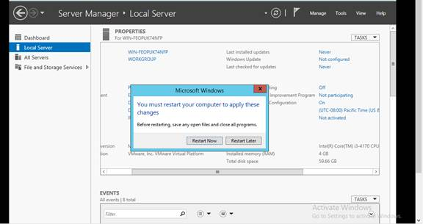
ADD Hyper-V feature in windows server 2012 and create a virtual machine.
Step21- Click on manage then click on Add Roles and features.
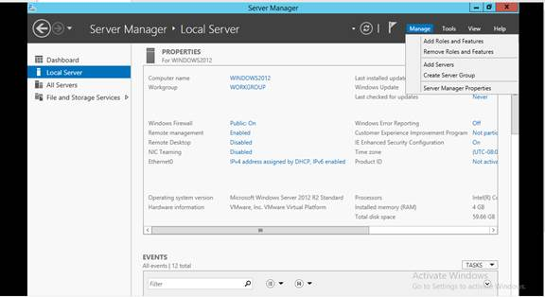

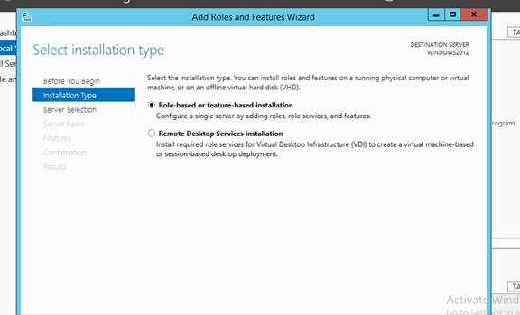
Step22- Select the server and click next.
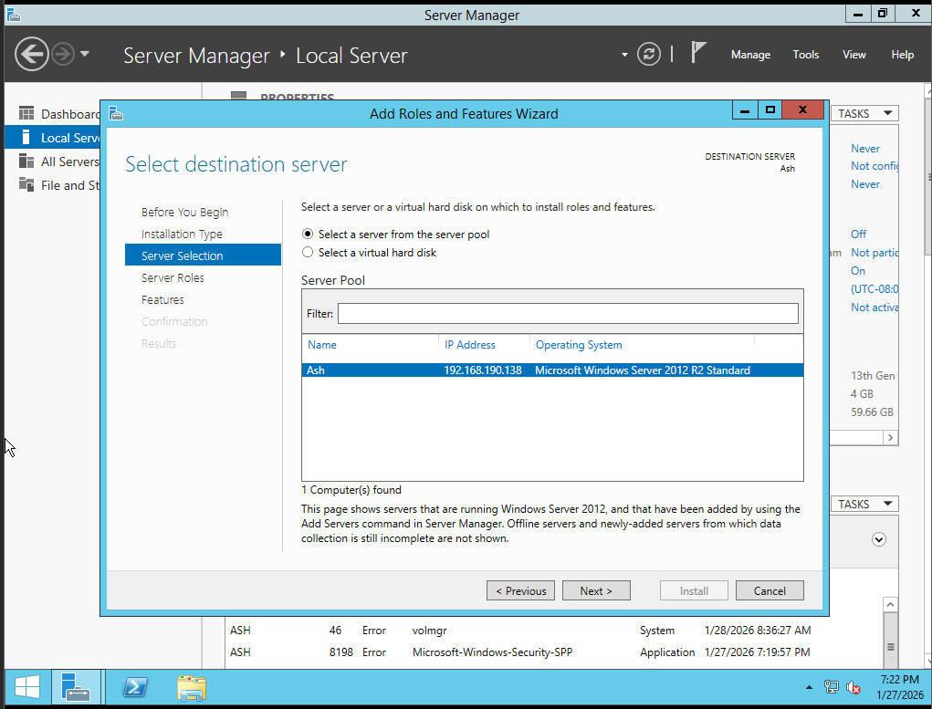
Step23-In Server Roles select Hyper-V then click on Add features and click on next. (Will not work)
Then Power off the Virtual Machine then go to edit virtual machine settings in that options tab in version select hypervisor (not supported)
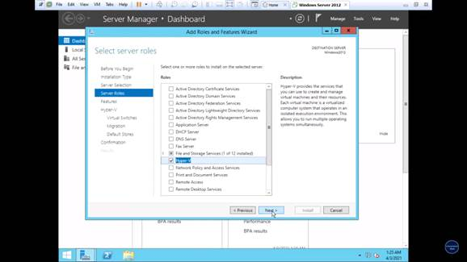
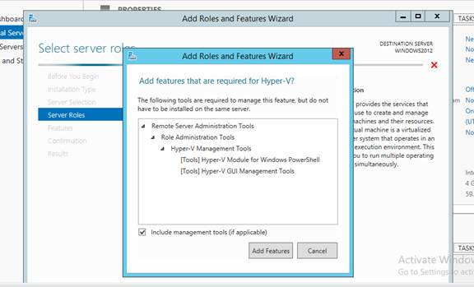

Step24-In Features select .Net framework 3.5 Features and click on next.
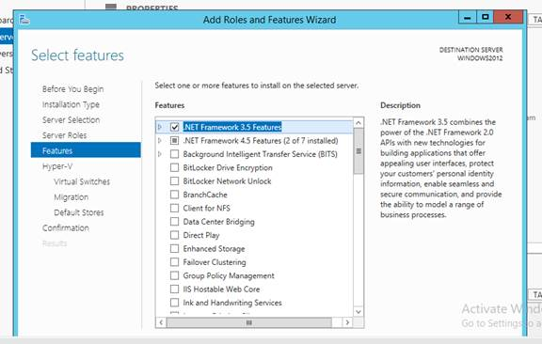
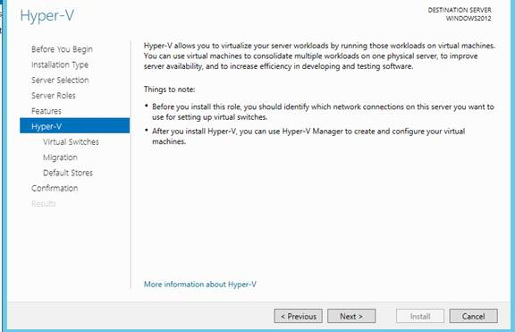
Step25- In Hyper V provide the virtual switches select Ethernet 0 and click on next.
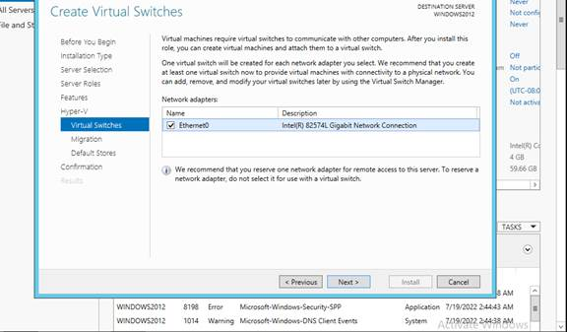
Step26-In Migration select the checkbox to allow and click on next.
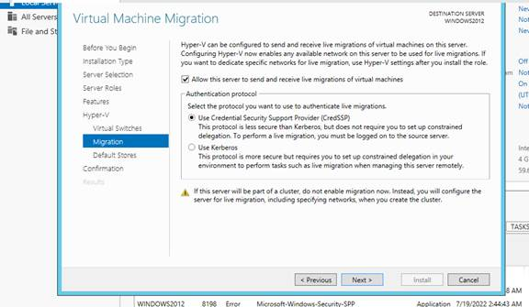
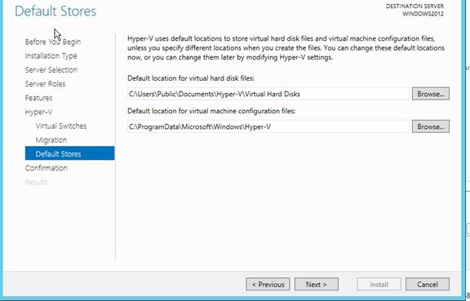
Step27-In confirmation click on install.

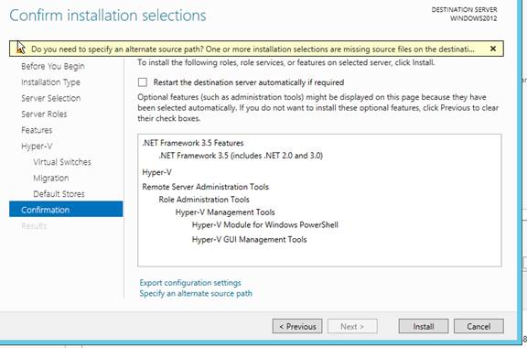

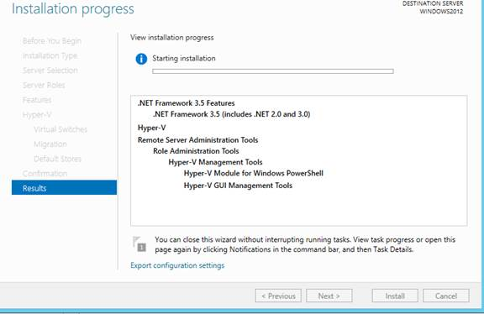
Step28- Now restart the Server.
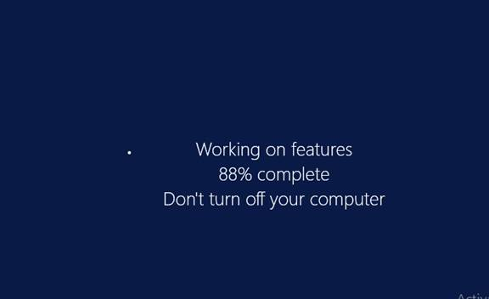

Step29-Now Login and click on Tools menu and select the Hyper-V manager.
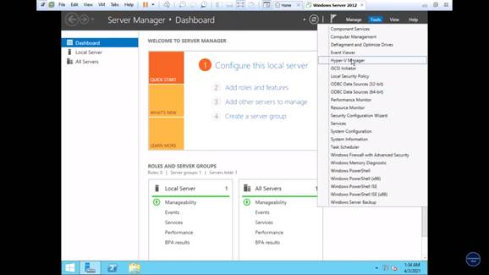
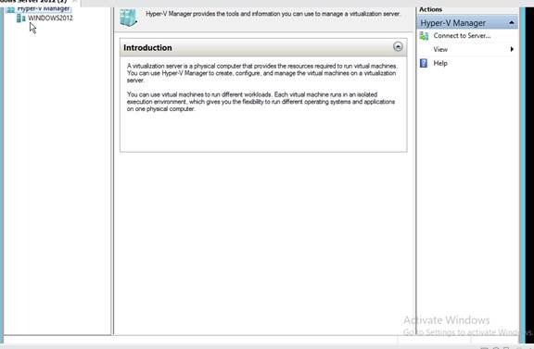
Step30-Right click on server then click on new and select the virtual machine and click on next.

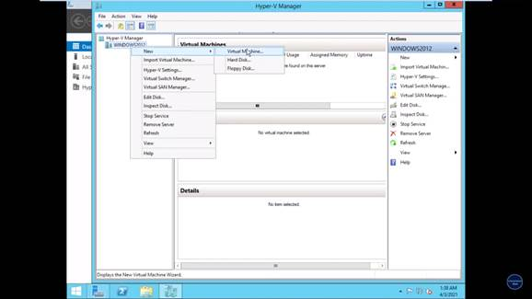

Step31-Give name to virtual machine ,location and click on next.

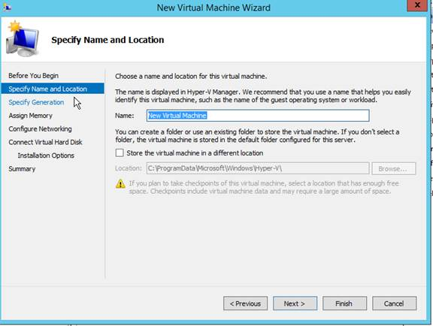
Step32-Select the generation and click on next

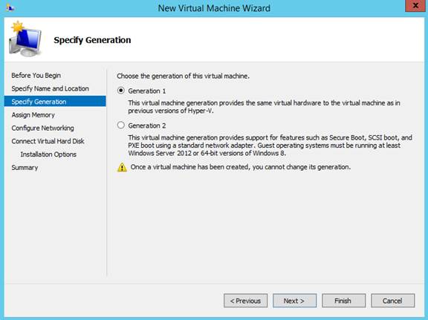

Step33-Assign the memory as 2 GB and click on next

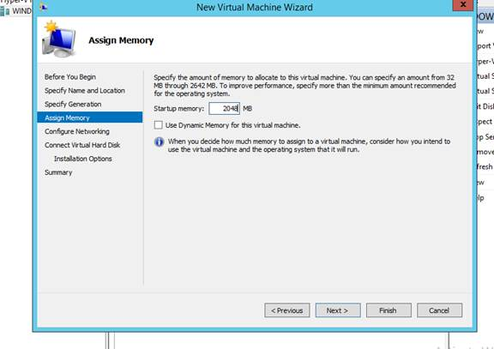

Step34-Select the network as virtual network and click on next

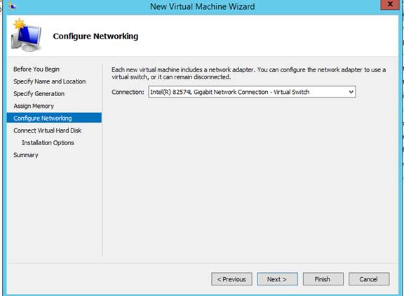

Step35- Select the virtual disk and its size and click on next.
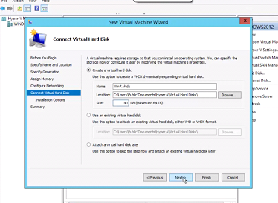

Step36- Now select install the operating system later and click on next and finish.
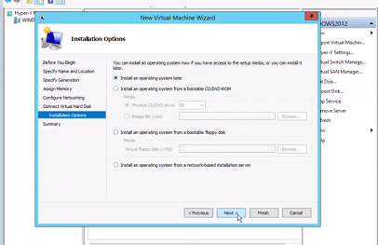
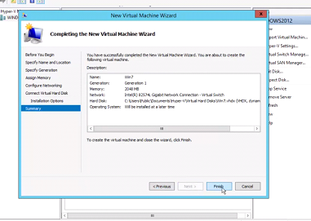
Step37-To assign the ISO files copy the ISO file and move to C drive or main drive in the system.
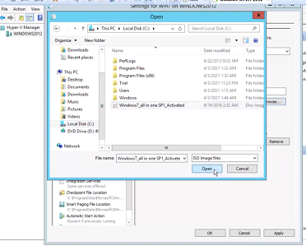
Step38- Assign the ISO to the virtual machine by clicking on settings then click on DVD drive and select image file option and add image file from drive and click on Apply and OK.
Step 38: Assign ISO File to the Virtual Machine
- Open Hyper-V Manager.
- Select the created Virtual Machine from the list.
- Right-click on the virtual machine and click Settings.
- In the left panel, select DVD Drive.
- Choose the option Image file (.iso).
- Click on Browse and select the required operating system ISO file from the drive.
- Click Apply and then click OK to save the settings.
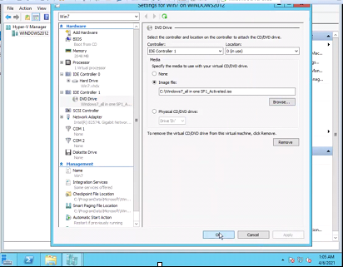

Step39-Select the virtual machine and click on start to start the installation process.
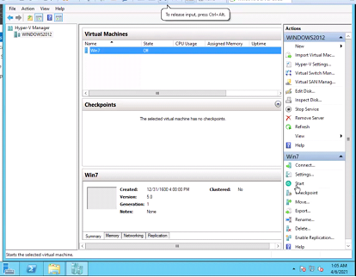

Step40-Complete the install process and use the virtual machine as your normal system by clicking on connect.
